|  |
| --- |
| Capstone Project - The Battle of Neighborhoods |
|  |

|  |  |
| --- | --- |
| 05-10-2018 | Live closer to work |

|  |
| --- |
| Utilizing Foursquare data to recommend place to live in New York. |

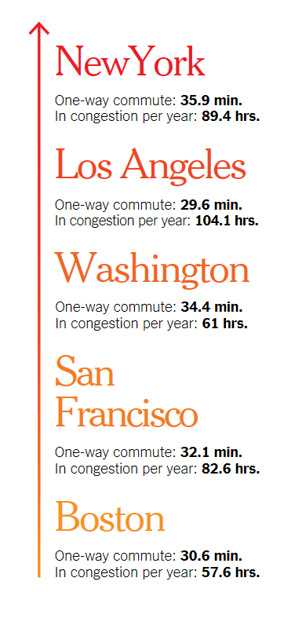Capstone Project - The Battle of Neighborhoods

Live closer to work

# **Introduction/Business Problem**

According to New York Times magazine, New Yorkers spend in average 35.9 min each way on commute to work every day. That’s the longest commute compared to all cities in USA. New York is also in the top of other inglorious competition – hours spent in congestion per year. Average New Yorker spends almost 90 hours per year in crowded, stuffy trains and subway platforms, only habitants of Los Angeles have it worse with average of 104.1 hours per year.

It’s a known fact that living closer to your workplace can save you stress, free up time for leisure and help increase your overall happiness. Why don’t people move closer to their work?

Choosing a right place to live is a complex optimization task in which you need to find a balance between low commute time and a very vague “general feeling” of the neighborhood. People don’t like change, and if they need to move to another place, wouldn’t it be comforting to know that the new neighborhood will be similar to the one that you’re leaving behind?

Business case for the analysis is creation of a tool, which for given current home address and work address will create suggestions of neighborhoods which resemble the one which customer is currently living in, but closer to the place they commute to every day. Leveraging Foursquare data, we want to capture the “general feeling” on the neighborhood and look for similar ones with lower commute time.

Figure 1 One-way commute time and hours per year in congestion. Source: New York Times.

Possible further development of the tool but out of scope for this project, would be directing customer to relevant apartment listings. There are many apartment listings sites, where customer can filter listings by features of apartments, but which doesn’t capture “general feeling” of the neighborhood.

# **DATA**

There are 3 main data sources which will be used to solve the problem:

1. Dataset of New York Boroughs and Neighborhoods with geographical coordinates, which can be accessed freely under link: <https://geo.nyu.edu/catalog/nyu_2451_34572>.
2. Foursquare data regarding venues in close location of neighborhoods.
3. Forge geolocator – to get geographical location of given addresses.

Example to illustrate how data will be used:

Mark currently lives in 1030 Neil Avenue, Bronx, NY and commutes every day to work at 545 5th Ave, Manhattan, NY. First, using Foursquare API get venues near 1030 Neil Avenue and create a profile for the neighborhood. After that, create similar profiles for all neighborhoods from the 1st data set. Find neighborhoods which are within e.g. ~ 1km range, ~ 2-5 km range and ~ 5-10 km range from 545 5th Ave and in each sector recommend a neighborhood which profile resembles surroundings of 1030 Neil Avenue the most. Mark will be left with three options, for which he can explore e.g. apartment listings to make a final decision.